EE130: Fundamentals of Electrical & Electronic Engineering I
Laboratory 2: Sine Wave Measurements

ID | 2 | 2 | 4 | 2 | 7 | 7 | 2 | 2 | 1BCT1

Reading:
Floyd, Sections 8-1 through to 8-7.

Objectives:
After performing this experiment, you will be able to:
- Measure the period and frequency of a sine wave using a TinkerCad simulation.
- Measure voltage differences in voltage divider circuits using TinkerCad.

Summary of Theory:
Imagine a weight suspended from a spring. If you stretch the spring and then release it, it will bob up and down with a regular motion. The distance from the rest point to the highest (or lowest) point is called the amplitude of the motion. As the weight moves up and down, the time for one complete cycle is called a period, and the number of cycles it moves in a second is the frequency. This cyclic motion is called simple harmonic motion. A graph of simple harmonic motion as a function of time produces a sine wave, the most fundamental waveform in nature. It is generated as the natural waveform from an ac generator. Figure 1 illustrates these definitions.

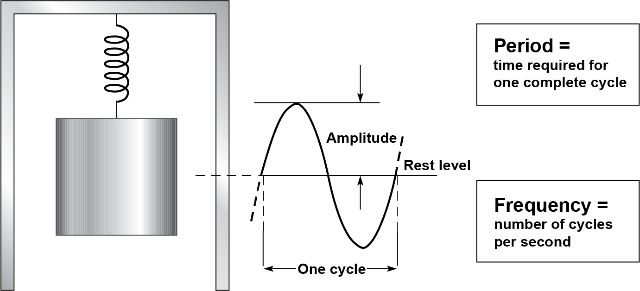
Figure 1

Sine waves can also be generated from uniform circular motion. Imagine a circle turning at a constant rate. The projection of the endpoint of the radius vector moves with simple harmonic motion. If the end point is plotted along the x-axis, the resulting curve is a sine wave, as illustrated in Floyd's text. This method is frequently used to show the phase relationship between two sine waves of the same frequency.
The sine wave has another interesting property. Different sine waves can be added together to give new waveforms. In fact, any repeating waveform such as a ramp or square wave can be made up of a group of sine waves. This property is useful in the study of the response of circuits to various waveforms.
The oscilloscope or scope is a powerful tool for viewing any waveform in a circuit. In this experiment, you will make timing measurements on sine waves. We will be using a virtual version of a digital oscilloscope. Rather than displaying a waveform as it occurs, the physical digital scope first acquires the measured analogue waveform and converts it to a digital format using an analogue-to-digital converter (ADC). The digital data is stored and processed. The data then goes to the reconstruction and display circuits for display on an LCD screen in its original analogue form.

TinkerCad Needs:
Tinkercad is a web-based design tool that does not require any software download. When you go to www.tinkercad.com, there is a “Sign Up” button on the top right where you can register an account for free. An introduction to the basics of Tinkercad for Electronic Circuits is available at https://www.tinkercad.com/learn/circuits and you can just click “Circuits” to start creating one.
Components: One 6.8 kΩ resistor, another resistor based on the first four digits of your student ID (e.g., 2233 Ω); a breadboard; two oscilloscopes; a function generator.

Procedure:
- Add a function (signal) generator in TinkerCad with a 1.0 V_{PP} peak-to-peak (amplitude) sine wave at a frequency of 1.25 kHz and a DC offset value of 0. Then connect the output of this function generator to a virtual oscilloscope (scope for short). TinkerCad may automatically scale the waveform on the oscilloscope to show one complete cycle on the screen. If it does not, you can manually change the time (in seconds) per division by clicking on the scope. The virtual oscilloscope shows the full height of the screen in volts and the full width of the screen in seconds. You can also manually change the width by clicking on the oscilloscope, and setting the time per division value to 0.1 ms/div (or 100 µs/div) in order to show one complete cycle on the screen.The expected time for one cycle (the period) is the reciprocal of 1.25 kHz, which is 0.8 ms. If the oscilloscope shows 1 ms for the full width of the screen (10 divisions), one cycle requires 8.0 divisions across the screen. This is presented as an example in line 1 of Table 1.
- Change the function (signal) generator to each frequency listed in Table 1. Complete the table by computing the expected period and then measuring the period with the oscilloscope. You can also adjust the time per division setting to show between one and two cycles across the screen for each frequency so that it is easier to measure the time period.

Table 1
Signal Generator Dial Frequency | Computed Period | Oscilloscope Time per Div | Number of Divisions | Measured Period
1.25 kHz | 0.8 ms | 0.1 ms/div | 8.0 div | 0.8 ms
1.90 kHz | 0.53 ms | 0.1 ms/div | 5.5 div | 0.55 ms
24.5 kHz | 0.04 ms | 0.005ms/div | 8.0 div | 0.04 ms
83.0 kHz | 0.0120 ms | 0.003 m/s div | 6.0 div | 0.018 ms
600.0 kHz | 0.0017 ms | 0.0002 ms/div | 8.5 div | 0.0017 ms

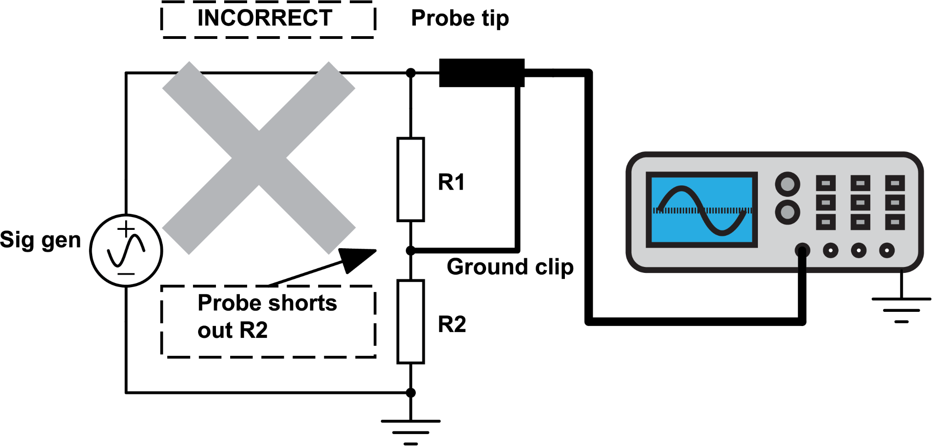
Figure 2

- In this next step, you will need to use two virtual oscilloscopes in TinkerCad, one connected across each resistor, for the circuit shown in Figure 3.
Side note: If you were actually building this physically with a two-channel oscilloscope, since R₁ is not grounded, you would have to subtract the voltage across R₂ from the total voltage being provided by the signal generator (top to bottom) in order to calculate the voltage across R₁ (otherwise the probe would short out R₂ as shown in Figure 2, since it adds an undesired ground path in the circuit).
For this simulated circuit in TinkerCad, the two oscilloscopes are separated from each other, and therefore we can just connect one virtual oscilloscope across R₁ and another one across R₂.
- It would be useful if both virtual oscilloscopes had the same vertical sensitivity – that is, if the VOLTS/DIV setting was the same on both oscilloscopes, so that the voltage differences across each resistor would be on the same scale. However, the virtual scopes in TinkerCad will automatically size to fit the waveform, so you can read the amplitude of each waveform as a portion of the overall number of volts for 10 divisions (top to bottom).

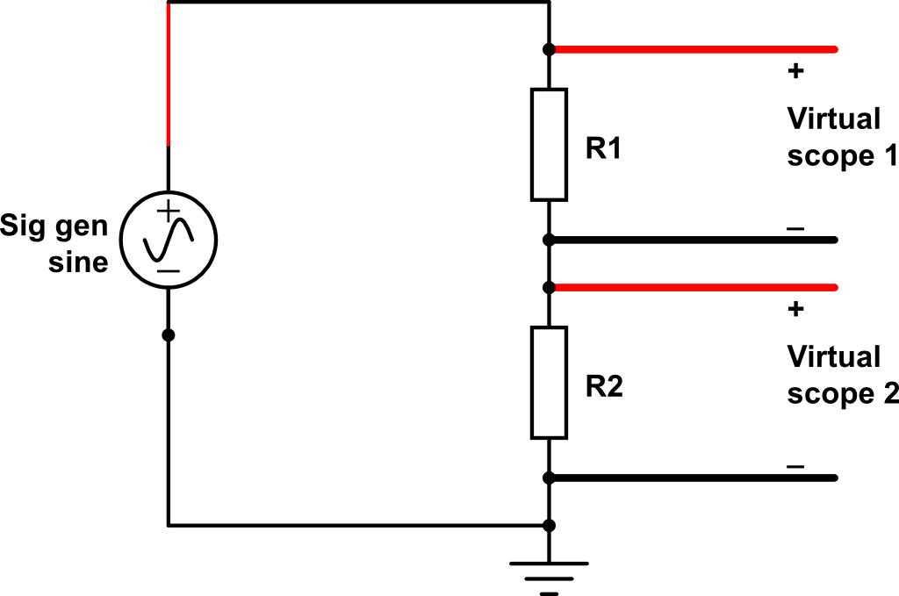
Figure 3

Connect the circuit shown in Figure 3, using a breadboard in TinkerCad to place the resistors. Use a resistor equal to the first four digits of your student ID for R₁ and a 6.8 kΩ resistor for R₂. Set the function generator for a 1.0 V_{PP} sine wave at 10 kHz. Scope 1 should show the voltage across R₁. Scope 2 should show the voltage across R₂.
Complete Table 2 for the voltage measurements. Use the voltage divider rule to check that your measured voltages are reasonable (note that the voltage divider rule works just the same for AC values, e.g., the peak-to-peak of a sine, as for DC values).

Table 2
 | Signal Generator Voltage | Voltage across R₁ | Voltage across R₂
Measured | 1.0 Vpp | 0.227V | 0.782V
Computed | 1.0 V_{PP} | 0.247 V | 0.752 V

Conclusion:

In conclusion, we can see that the higher the frequency, the oscillioscope time per div lowers, as does the measured period (the time it takes to complete one cycle).
Also, we can see that the voltage divider rule applies the same way for AC and DC values.

Evaluation and Review Questions:

- Using the measured voltages in Table 2, show that Kirchhoff's voltage law is satisfied.

- An oscilloscope display shows one complete cycle of a sine wave in 6.3 divisions. The time (seconds) per division setting is set to 20 ms/div.

  - What is the period? _____126ms_______________

  - What is the frequency? ____7.9hZ________________

- You wish to display a 10 kHz sine wave on the oscilloscope. What setting of the time per division control will show one complete cycle in 10 divisions?

Time (seconds) per division (SEC/DIV) = ___0.01_________________

